Update the TNT new rate charge, changes detail:

- Rates.xls – using TNT Sell Rate - APHUb.xls, because we’re based on COUNTRY. The other file TNT-Schenker.xls do not have country column.

- Invoicing template formula:

  - TNT additional server charge column – to manual input the total service amount.

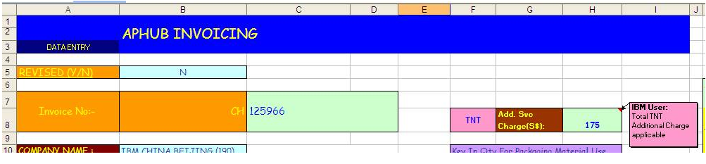

  - TNT Exchange Rate (USD to SGD) : tab [Monthly Update]

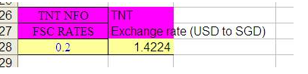

  - Charge rates calculation:
** Convert TNT USD Charge rate to SGD $ then convert to USD$ (IBM Charge rate)

Refer to below example:
Based on 100kgs of shipment,
Min charges (Min 10kgs) = USD 763
Subsequently USD 8 per kg = 90kgs x USD 8 = USD 720
Weekend surcharge = USD 100
After office hour surcharge = USD 75
Total charges == USD 1658

Total charge rate = $1658 (TNT RATE)
Converted to USD = $1658 * (TNT exchange rate) / (SGD to USD rate)
= $1658 * 1.4224 / 1.267
= USD $1861.26

